May 7, 2007

To: Leadership Committee

From: Ed Means
Andree Hunt
Malcolm Pirnie, Inc.

Subject: Memorandum on the Greater Los Angeles Integrated Regional Water Management Plan (LA IRWMP) Decision-Making Structure Analysis

Introduction

The purpose of this technical memorandum is to:
- Reflect the tenor of stakeholder discussions regarding decision-making in the current LA IRWMP effort.
- Describe other decision-making models that may be instructive to the Leadership Committee (LC), Steering Committees (SCs) and Stakeholders
- Provide observations on potential modifications to the current decision-making structure to improve functionality and transparency.
- Provide alternatives that reflect these observations for revisions to the current Interim Guidelines for the Formation, Composition and Operation of the Regional Water Management Group for the LA IRWMP (Guidelines)

Background

In order to develop the LA IRWMP, an interim decision-making structure had to be adopted quickly to ensure completion of the plan within the time frame for Round One of Prop 50, Chapter 8 funding. Pursuant to the Prop 50 IRWM Grant Program Guidelines, a Regional Water Management Group had to be established in order to obtain grant funds. This group had to include three or more local public agencies, at least two of which had statutory authority over water management, and had to be established by means of a joint powers authority, memorandum of understanding, or other written agreement approved by the governing bodies of those public agencies. To create a Regional Water Management Group for the Region, an MOU was adopted and signed by twenty-eight agencies and organizations.

In addition to the MOU, interim operating guidelines for the development of the plan were adopted, creating a decision-making structure with five sub-regional SCs and a LC. This structure enabled the successful development of the LA IRWMP that resulted in $25 million in Prop 50 funding.

With the specter of Proposition 84 funding and other monies on the horizon, establishment of a long-term, broadly supported decision- making structure is particularly important to help guide the region, accommodate the variety of sub-regional interests, and ensure that, to the extent possible, the region speaks with a powerful and cohesive voice.

A consultant team has been working with LC and SC members to identify and implement appropriate modifications to the current decision-making structure. Participants in this effort now have an opportunity to reflect on the advantages and disadvantages of the decision-making structure prior to adopting a long-term decision-making structure for plan implementation.

Approach

To determine the concerns about the current decision-making structure, the consultant team conducted telephone interviews with available LC members or a designated representative. For input from the broader stakeholder base, the consultant team also facilitated discussions with each SC during February and March 2007.

For insight on the benefits and drawbacks of other decision-making structures, the consultant team reviewed the decision-making structures of three IRWMP regions and three comparable regions, utilizing published materials as well as telephone conversations with representatives from the groups. These entities included:
- North Coast IRWMP
- Bay Area IRWMP
- South Orange County IRWMP
- California Urban Water Conservation Council
- Santa Monica Bay Restoration Commission, and
- Santa Ana Watershed Project Authority.
The consultant team then prepared a matrix which summarized key aspects of the decision-making models of these groups.

Based on these discussions and research, observations on the long-term decision-making structure for the LA IRWMP have been formulated and are described in this memorandum.

Description of Current Structure

The LA IRWMP is currently governed by a Memorandum of Understanding (MOU) and Interim Guidelines for the Formation, Composition and Operation of the Regional Water Management Group for the Greater Los Angeles County Integrated Regional Water Management Plan (Guidelines). Under the current structure, the LC is the decision-making body responsible for formal decisions regarding the scope and content of the plan. Five sub-regional SCs, comprised of representatives appointed by member agencies and organizations, provide input to the LC on major issues contained in the plan.

The LC is comprised of eleven voting members. The Chief Engineer of the County Flood Control District chairs the committee (and provides perspective on flood control matters). Each of the five SC Chairs also serves as a member on the LC. The additional five LC members serve as “water management area” representatives. There are five water management areas:
- Groundwater,
- Surface Water,
- Storm water Management/Quality,
- Sanitation, and
- Habitat/Open Space.
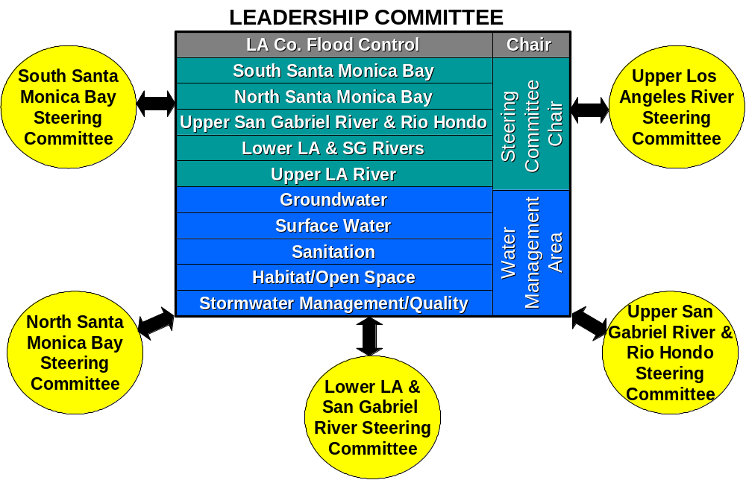

Figure 1: LA IRWMP Decision Making Structure

Each SC nominates three potential water management area representatives, and from the pool the first six members of the LC select the five representatives. The Guidelines indicate that the LC should strive to have one water management area representative from each sub-region, but this balance is not required. The LC meets monthly or as needed and is supported by a consultant team and agency staff.

The SCs contain executive level representatives from agencies and organizations involved in local water management within each sub-region. Representatives to the SC are informally appointed by and serve at the pleasure of their respective agencies or organizations. Specific guidelines or rules for selection of SC members do not exist; to date, the SCs have operated as a group of interested agencies and stakeholders willing to devote the time to help guide the sub-regional activities and provide input to the LC. Each sub-region has different water management needs and contains a different combination of public agencies. As a result, each SC operates slightly differently, reflecting the character and priorities of the sub-region. SCs are staffed by members of the consulting team and meet approximately monthly. This approach has, by nearly all accounts, worked well to date.

Both LC and SC meetings are open to the public and announced on the website. Public participation from the meetings and from stakeholder workshops has been the means by which public input is incorporated into the planning process. “Non-member” attendance at SC meetings generally declined to a core group of participants as the LA IRWMP was completed and adopted.

Description of Other Structures

As part of the data collection effort, Malcolm Pirnie evaluated the decision-making structures of several other IRWMP regions as well as other governmental and non-governmental organizations. These structures are summarized in Attachment 1 and described below.

South Orange County IRWMP

A draft agreement to implement the South Orange County IRWMP was completed in early February, 200?. This agreement, which was modeled after the Newport Bay TMDL agreement and the Stormwater Program agreement, provides for cost-sharing and an annual work plan, but does not establish the Regional Water Management Group as a legal entity because the parties did not want to create a new governmental body. The draft agreement differs from the previous leadership structure in that it provides for elected officials, rather than agency staff, to serve as the decision-making body.

Originally, the South Orange County IRWMP was developed at staff level and then taken to the individual boards of participating agencies for approval. Public agencies led the planning process, and due to time constraints, non-governmental organizations (NGOs) and private interests did not participate in writing the plan. Stakeholder comments on the plan were received via public workshops. In the new South Orange County IRWMP agreement, elected officials from public agencies and directors or officers from private organizations will serve as the representatives on the Executive Committee, which will approve the budget, work plan, and multi-year capital improvements plan. Executive Committee membership will be pay to play; only those agencies and private water utilities that participate in the cost-share will be part of the committee. The Executive Committee is intended to be a consensus-building forum, and its decisions will be more of a gesture than a legal agreement as the representatives will then take the decisions back to their individual boards for approval. The switch from staff-level to elected representatives is intended to bridge communication between the Executive Committee and the individual boards, as the Executive Committee members will be championing Executive Committee decisions to their peers on their respective boards.
The effectiveness of the new South Orange County decision-making structure has yet to be determined as it is still in the process of being formally adopted. Additionally, some aspects of the decision-making structure are still being worked out. For example, whether each participating agency will have a seat on the Executive Committee or whether there will be some sort of representational scheme has yet to be determined. The South Orange County region differs both geographically and politically from the Los Angeles region, and as a result, the decision-making needs of the regions may be different.

North Coast IRWMP

The North Coast IRWMP encompasses seven counties in its region. It has a decision-making body of elected officials supported by a technical committee and a project committee. The main decision-making body, the Policy Review Panel, consists of two representatives from each county appointed by each county’s Board of Supervisors. The Policy Review Panel provides oversight and direction for the IRWMP process. A Technical Peer Review Committee, which includes two representatives from each county appointed by each county’s representatives on the Policy Review Panel, provides technical support for the Policy Review Panel. Representatives on the Technical Peer Review Committee include agency staff, NGO staff, technical staff, and consultants. Each county appoints its own representatives to the Technical Peer Review Committee, and there is no requirement for a balance between public agency and NGO representation. A third committee, the Project Team, is comprised of consultants and staff from participating agencies and is responsible for the majority of project work, including development of project ranking criteria.

Regarding the effectiveness of the North Coast decision-making model, one aspect that worked well was having elected officials serve as the decision-making group during the planning process. One weakness during the planning phase was lack of public outreach. Representatives from the region indicated that the brief timeframe for plan development and adoption hindered public outreach efforts, and consensus was that more time will allow the region to develop stronger analytical criteria and increase stakeholder outreach.

Because the political and geographical structure of the North Coast region is significantly different from that of the Los Angeles region, it would be difficult to apply the North Coast decision-making model to the Los Angeles IRWMP. One aspect of the North Coast decision-making structure that could be effective in the Los Angeles region is a Project Team, comprised of consultants and representatives from agencies and organizations that do not have projects on the list. Such a group could assuage concerns about project proponents making decisions on project prioritization.

Bay Area IRWMP

Participants from the Bay Area IRMWP are currently in the process of reviewing the decision-making structure. The original Bay Area IRWMP Letter of Mutual Understandings (LOMU), signed by public agencies that led the planning process, was intended to foster the development of the plan; now that the plan has been developed, the LOMU has arguably expired and may not apply for plan implementation. The adopted Bay Area IRWMP states that the parties will continue with its current structure for the near term unless the review indicates that the structure needs to be modified.

Under the current structure, decision-making bodies include four service function technical coordinating committees and a San Francisco Bay Area Technical Coordinating Committee. The service function coordinating committees are comprised of staff-level representatives from public agencies within the region and include: Water Supply and Water Quality; Wastewater and Recycled Water; Flood Protection and Stormwater Management; and Watershed Management and Habitat Protection and Restoration. These committees are responsible for updating goals, objectives, and information on projects within their functional areas. Each service function coordinating committee operates differently, as some are extensions of previously existing entities while others are new groups. The Technical Coordinating Committee is comprised of two or three representatives appointed by each of the service function coordinating committees and has decision-making authority for development and implementation of the plan. Technical Coordinating Committee meetings are open to the public to allow for stakeholder participation.

The issues that have come up thus far in the review of the Bay Area IRWMP decision-making process include whether NGOs and disadvantaged community representatives should have decision-making authority, whether the elected officials rather than staff-level representatives should serve as the governing body, and whether sub-regional representation should be incorporated into the Technical Coordinating Committee. No decisions have been made thus far on whether to modify these aspects of the management structure for the IRWMP implementation.

Of the three IRWMP decision-making structures reviewed, the Bay Area IRWMP structure is most similar to the Los Angeles IRWMP decision-making structure. The main difference between the two is that the representational scheme in the Los Angeles region allows for representation on a sub-regional basis. Another difference is that the Bay Area had pre-existing organizations representing most service-function entities within the region. As participants in the Los Angeles IRWMP have expressed a desire to increase decision-making at the sub-regional level, the Bay Area IRWMP decision-making structure would not be practical for the region.

California Urban Water Conservation Council

The California Urban Water Conservation Council (CUWCC) was created to increase efficient water use by integrating urban water conservation Best Management Practices into water resources management and planning. Council members, including urban water agencies, public interest organizations, and private entities, are divided into three groups: Group 1- Water Suppliers; Group 2- Advocacy Organizations; and Group 3- Other Interested Groups. Only those members in Group 1 and Group 2 participate as voting members, and those groups are given equal weight in the voting process. To pass any decision requires a vote in favor by Group 1 and a vote in favor by Group 2.

The SC serves as the Board of Directors of a non-profit corporation and is responsible for the business and affairs of the CUWCC. It is comprised of: up to eight Group 1 representatives, up to eight Group 2 representatives, and up to four non-voting signatories selected by Group 3; one designee from each of those State and Federal agencies selected by the SC (non-voting); and the former Convener (non-voting) for the year following his term. The SC is responsible for general management activities and cannot modify the Best Management Practices or MOU as that right is reserved by Council members.

As the CUWCC has nearly 400 member agencies and organizations throughout the State, it requires a formal decision-making process. For the LA IRWMP, such a structure for the Region could inhibit the discussions and collaboration among stakeholders that have made the process successful thus far. Additionally, a model that requires majority approval from both agencies and advocacy groups could slow the decision-making process, creating difficulty in obtaining grant funds

Santa Monica Bay Restoration Commission

The primary mission of the Santa Monica Bay Restoration Commission (Commission) is to facilitate and oversee the implementation of the Santa Monica Bay Restoration Plan. The Commission became an independent state organization via legislative action in 2003 and is established within the State Water Resources Control Board, with funding appropriated by the Legislature.

The decision-making body for the Commission, the Governing Board, is comprised of 35 members- 20 voting and 15 non-voting- from a combination of agency appointments, ex-officio seats, and elected representatives. Nine of the voting members are elected by the Bay Watershed Council, which is the broad stakeholder body of the Commission that is comprised of all groups who participated in the Santa Monica Bay Restoration Plan prior to 2002. Of those nine, one is the President of the Bay Watershed Council, three represent cities (either city mayors or council members), two represent environmental/public interest groups, one represents business/economic interests, and two are members at large. The remaining members of the Governing Board are representatives from Federal, State, and local public agencies. In accordance with the Bagley-Keene Open Meetings Act, the Governing Board publicly notices its meeting, prepares agendas, accepts public testimony, and conducts its meetings in public unless specifically authorized to meet in closed session.

The Commission also has a Technical Advisory Committee, which deals with the technical and scientific interests and concerns of the Commission. The Technical Advisory Committee is appointed by the Governing Board and is made up of scientific and technical professionals from governmental agencies, universities, research institutions, and environmental organizations. Its purpose is to ensure that the Commission has the necessary scientific and technical information upon which to base its decision-making.

As lack of representation of cities and environmental groups has been a concern expressed by some participants in the IRWMP, a balance of representation between agencies, cities, and environmental interest groups similar to that of the Commission could provide for a broader representation of interests. A challenge would be to apply such a balance to the LC while also maintaining equal representation from each of the five sub-regions. To ensure such a balance, it is likely that the size of the LC would need to be increased. Another option would be to apply this representational scheme at the SC level.

Santa Ana Watershed Project Authority

The Santa Ana Watershed Project Authority (SAWPA) is responsible for planning and building facilities to protect the water quality of the Santa Ana River Watershed. SAWPA is a Joint Powers Authority and is classified as a Special District under California state law. It is comprised of the five largest agencies in the Santa Ana River Watershed, and all of its decisions are made by these agencies.

All of the power and authority of SAWPA is exercised by its Commission, subject to the reserved right of members with regard to approval or budgets and assumption of financial obligations. The Commission includes one representative appointed by each agency, either a member of its governing body or its General Manager. A Technical Committee of General Managers, comprised of the general managers of each member agency, reviews and makes recommendations on all technical and financial issues before these issues are considered by the commission.

With the exception of administrative and study matters benefiting all member agencies, SAWPA operates on an individual project basis. A project may include all or some of the member agencies, and an individual budget which outlines the contributions of each involved agency is adopted for each project. For each project, those members of the Commission whose agencies will be involved in and funding the project constitute the Project Committee.

As SAWPA is limited in membership to five public agencies, it does not require multiple layers of decision-making as the IRWMP process does. One component of SAWPA that could be applied to the Region is a two-tiered budget system, with both a general administrative budget adopted by all participating groups and individual budgets adopted by participants in specific planning activities.

Los Angeles and San Gabriel Rivers Watershed Council Recommendations

The Watershed Council provided a letter detailing its recommendations for improvements to the IRWMP decision-making structure. In this letter, the Watershed Council suggested increasing LC size to 21 members: three from each of the SCs, three from regional agencies, and three from non-profit organizations serving a majority of the region. The representatives from regional agencies and non-profit organizations would not serve on any SC. SC representatives would be rotated as necessary to maintain balanced representation between public and private water supply companies and wholesale and retail suppliers of water.

IRWMP Regional Workshop #3 Stakeholder Input

During the regional workshop in August 2006, stakeholder input on the IRWMP decision-making structure was obtained in breakout sessions. Stakeholders indicated that, while a regional entity is necessary to advocate for funding, a “bottom-up” approach with buy-in from the public and local support is key to the success of the process. Such an approach would be developed by increasing the role of NGOs and by maintaining sub-regional organizations within the regional structure to ensure that sub-regional differences in needs are taken into consideration.
Stakeholders also discussed long-term funding options. Suggestions included: increasing Stormwater fees and/or water rates; introducing and promoting legislation that would provide maintenance funds; implementing a maintenance and endowment fund that would be funded by excess local and county tax revenues; and assessing user fees for top social pollutants (i.e., cigarettes) to be used to operation and maintenance of IRWMP projects.

Leadership and Steering Committee Feedback and Analysis

Structure

In general, feedback from the LC (LC) and Steering Committees (SCs) fell into three broad areas:
- Representation,
- Transparency,
- Funding

There were broad accolades for the accomplishments of the process over the last year with many acknowledging the remarkable production of a regional plan within a very short time period as well as the development of lines of communication among stakeholders that did not exist prior to the effort. The awarding of $25 million in grant funding to the region as a result of the planning process was cited as proof of the merit and success of the process.

1. Representation - All acknowledged that future progress towards implementing the plan would depend on solid regional and sub-regional participation and that any decision-making structural changes should serve to strengthen participation and “buy-in”. Most believed that strong sub-regional representation and advocacy for the process is vital. Most of the LC and SC members interviewed indicated that the number of people and the balance of interests on the LC were correct. Most were also satisfied with having agency staff with technical knowledge on water management in the decision-making capacity as well as consultant support for the committees. Several expressed concern that an expanded LC could become unwieldy. However, there was a view articulated by several individuals that the current structure of the LC was unnecessarily excluding greater engagement by the sub-regional SCs and stakeholders (including NGOs and others). This is a sore point among some in the region and a significant hurdle to future progress in our opinion.

On the topic of chairmanship, LC members overall expressed satisfaction with having the County serve as the chair. Reasons included the County’s impartiality, jurisdiction over the entire region, and relationship with the Board of Supervisors which provide significant political support for the actions of the LA IRMWP process. Among LC members, the only concerns expressed regarding continuing the County’s chairmanship were the potential constraints on the County to participate as an interest group while acting as a neutral chair and the need for a chair to be more forceful in running the meetings.

To address these concerns, two of the LC members suggested hiring an outside facilitator to run the meetings, which would allow the County to participate as an interest group but would necessitate additional long-term funding. Most SC members were also satisfied with the County’s role as LC Chair, although some indicated that the County’s interests were over-represented on the LC and that smaller entities, such as cities, should be given a greater voice on the LC.

Participants were generally satisfied with having the five sub-regional chairs and five water management area representatives on the LC, but many indicated that the SC members, rather that the first six LC members, should select the water management area representatives. Additionally, many participants thought that a balance of one water management area representative from each SC should be mandated by the guidelines, as the current guidelines recommend that balance but do not require it.

A few participants suggested that LC size should be increased. Suggestions included expanding the LC size to three representatives per sub-region and making some ex-officio members voting members. The advantage to this would be that a broader range on interests could be represented on the LC; the disadvantage would be that decision-making and voting at the LC level would become more difficult if the number of members were increased.

Some participants also indicated that representation from non-profits should be added to the LC in either an ex-officio or voting role. Those who recommended this indicated that a broader range of viewpoints on the LC would be beneficial and that a greater range of interests would be represented in the decision-making. Those who opposed adding non-profit representation to the LC expressed concern than non-profits do not have jurisdiction over water management and are not accountable to the region’s constituency as they do not have an elected board.

Most participants also indicated that setting term lengths for LC members would be beneficial. The primary reasons were that terms would require SCs consciously reaffirm or replace their representatives to ensure continued sub-regional support and representation at the LC. Most participants believe that term limits would be detrimental as they would force out the people who have the time for, passion for and knowledge of the process (as well as the support of the SC).

Steering Committee Structure - While most participants were satisfied with the basic decision-making structure, many felt that a greater degree of decision-making should take place at the SC level. When asked to define what the role of the SC should be, most of the SC members and many of the LC members stated that the SCs should be responsible for maintaining sub-regional goals, prioritizing projects, and outreaching to local stakeholders. Many SC members felt that decisions on which projects to fund should also be made by the SCs.

Discussions regarding representation at the SC varied greatly between sub-regions. Some indicated that more representation from non-profits is needed; others felt that cities were not adequately represented; and others felt that the range of representation was good as is. Because of the differences between the sub-regions, it appears unlikely that applying a uniform structure to the SCs would be effective in engaging a broad range of stakeholders from each sub-region.

2. Transparency - Consensus among interviewees was that transparency of the LC is an area for improvement. Specifically, LC and SC members expressed confusion as to what the action items were in LC meetings and indicated a desire to see minutes following the meetings. Many participants indicated that having agendas and minutes from LC meetings posted on the website and distributed to stakeholders would be beneficial. Similarly, some expressed the view that the project selection process must be free of any conflict of interest by decision makers. To this end, some felt that individuals involved in prioritizing projects should recuse themselves if they have projects on the list.

LC members also expressed a need for a more formal meeting structure. Both LC members and other participants indicated that it was difficult to determine who was voting in the meetings and what was being voted on. Most of the LC members were in favor of changing the layout of the room to enable meeting participants to differentiate between voting members and interested parties. Some suggested adding a public comment period to the LC meetings, either at the beginning of the meeting or before each issue, to ensure an opportunity for public input.

There was broad consensus on the need to formalize the roles of both the LC and the SC. For plan implementation, participants envisioned a LC that assumes the following responsibilities:
- Provide regional oversight to the LAIRMWP
- Track regional progress towards the LA IRWMP targets,
- Act as liaison between the State and the SCs,
- Represents the region’s needs to the State,
- Provide a balance for sub-regional interests,
- Find, coordinate and pursue funding opportunities,
- Determine how to divide regional grant funding equitably,
- Provide regional outreach related to the LA IRWMP, and
- Periodically update the LA IRWMP.

Interviewees indicated the SCs should assume the following responsibilities:
- Represent sub-regional interests,
- Provide outreach to local entities and communities to ensure adequate input from all stakeholders,
- Maintain sub-regional prioritized project list,
- Allocate grant funding for the implementation of these projects,
- Maintain a list of sub-regional goals and priorities,
- Develop, as appropriate, sub-regional goals and targets (this varied by sub-region),
- Track progress on sub-regional goals and planning targets,
- Identify and sponsor sub-regional planning studies as needed.
- Work with the LC to update the Plan as needed.

3. Funding and Staff Support - Participants agreed that an arrangement for long-term funding and staff support would be necessary for plan implementation. Many indicated that, while agencies provided the contributions necessary for the plan development, a funding system with an equitable basis will be necessary to carry out future activities. Additionally, participants indicated that the County has provided a significant amount of the staff support for the plan thus far and that staffing costs should be spread more equally for implementation.
Several options were identified for ongoing staff support including:
- Hiring of dedicated staff – this would provide a dedicated and focused staff to implement the transparency measures previously discussed and “drive” the process. It would also more the organization to a more official “agency” status which some viewed as very undesirable (i.e. bureaucratic). This was viewed as making the plan “less responsive” to the local agencies and sub-regions.
- Use of agency staff to provide the support – this is occurring currently but participation level varies among the agencies. Significant in-kind staff time has been contributed to date and will likely need to continue as the plan is implemented.
- Use of consultants – consultants has been used to date. This will require cash outlay on the part of the participating agencies (as opposed to in-kind services). Greater expenses related to implementing the transparency measures discussed above will be likely.

Each of these options present advantages and disadvantages and will require ongoing in-kind funding (in the case of internal staff) and cash funding (in the case of a dedicated staff or consultant support). Funding strategies were not within the scope of this evaluation but represent a clear need going forward.

Observations for Leadership Committee Consideration

Based on the interviews and research of other decision-making structures, the following modifications to the decision-making structure should be considered.

Representation:

1. The duties and powers of both the LC and SCs, as articulated in the interim Guidelines, could be updated to include the following.

The LC shall:
- Update the LA IRWMP periodically.
- Maintain a list of regional goals, targets, and prioritized projects.
- Track progress towards regional goals and planning targets.
- Maintain a prioritized regional project list with input from the SCs.
- Develop an annual shared-cost budget for staff support and administrative costs associated with plan implementation.
- Develop and maintain a method for the equitable allocation of funding to the sub-regions.
- Coordinate and represent regional IRMWP activities with and between the sub-regions, the State and stakeholders.
- Provide information on legislation and funding opportunities to the SCs.
- Advocate for regional funding and represent the region’s IRWMP interests to the state.
- Provide meeting agendas and minutes to SCs, and post these agendas and minutes on the designated website.
- Coordinate with the SCs.

The Steering Committees shall:
- Represent sub-regional interests.
- Provide outreach to local entities and communities to ensure adequate input from all stakeholders.
- Maintain sub-regional prioritized project lists and ensure the LC’s master list is current.
- Maintain a list of sub-regional goals and priorities as appropriate.
- Track progress on sub-regional goals and planning targets (where applicable).
- Identify and sponsor sub-regional planning studies as needed.
- Work with the LC to update the Plan as required.

2. To increase representation at the LC, the current membership could be expanded to allow each SC to appoint three members to the LC (see Figure 2 below). This would effectively expand the size of the LC to sixteen but would help address the concerns of several interviewees for added representation for sub-regional interests (whether they are NGOs, local agencies, cities or other stakeholders). The SCs would be responsible to determine how best to select those individuals as well as responsible for their performance. The process should seek individuals that can commit the time and ably represent the sub-regions interests before the LC. The County would retain the Chair position to maintain connection to and support of the County Board of Supervisors.

While the representation of the individual water management areas would not be guaranteed by this system, the likelihood of representatives being appointed by the SCs that lack such skills as a group is small. Further, the staff supporting the appointees will likely have some or all of these skills.

Figure 2: Expanded Leadership Committee Consisting of Three Appointees from Each Steering Committee and the County as Chair

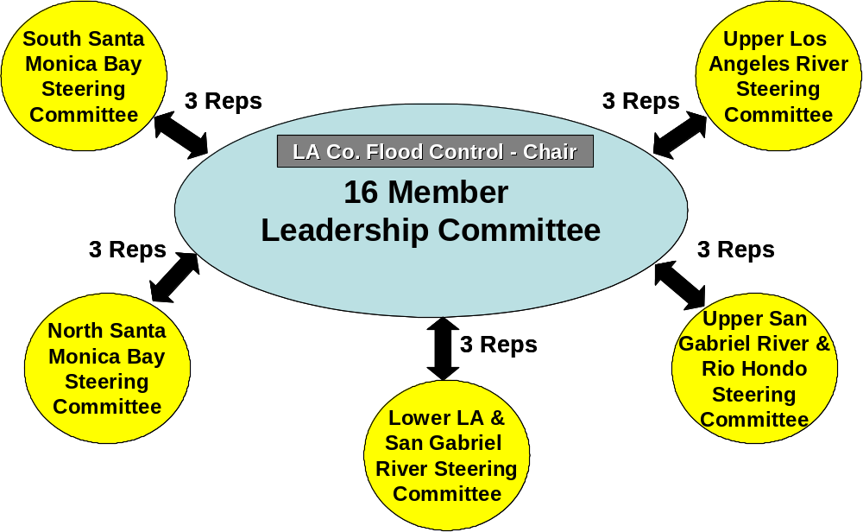

3. Terms should be established for LC members. The terms of LC members could be at least three years and rotated with one position per SC reappointed at the end of year three, one at the end of year six, and one at the end of year nine and so on. LC members may serve at the pleasure of the SC and may serve consecutive terms.

Transparency

    - Decisions on project prioritization and readiness should be made by a group, consultant or otherwise appropriate, that does not include proponents of any projects on the list.

    - The Leadership Committee should prepare and circulate agendas in advance of their meetings. The Steering Committees should have an opportunity to discuss those agendas where possible.

    - Time for public comment should be allocated at the beginning of each LC meeting.

    - Minutes from LC meetings should be posted on the website and distributed to stakeholders.

    - The LC seating arrangement should be reconfigured in a board format to make clear the responsibility of the appointees.

    - Key action items of the LC should be submitted in a simple board letter format such that subsequent interested parties can review and understand the recommendations and actions

Funding

In order for the LA IRWMP to be a stable advocacy force, mid-term funding is required, particularly as Proposition 84 and other monies are disbursed by the State of California. Many indicated that, while agencies provided the contributions necessary for the plan development, a funding system with an equitable basis will be necessary to carry out future activities. This will require a commitment on the part of the sub-regions to contribute resources to support the LA IRWMP decision-making process. To this end, consider:

- Establishing a “mid-term” operating budget (4 years). This conforms to the Proposition 84 grant funding cycle for IRWMP projects. At the conclusion of this period, the LC and SCs can re-visit the direction of the LA IRWMP and long-term support strategy.

- Obligating the six parties (five SCs and the County) to equal shares of the three-year budget. Failure to pay the up-front three-year share would remove the entity from participation in the LC and regional advocacy process for grant funding. The sub-regions would be responsible to determine how to fund their share. This cost share could value in-kind assistance as well as cash contributions. For example, one region might agree to be responsible for preparing agendas and minutes, the County would be credited for maintaining the website or coordinating activities, LC letters might be prepared and credited to a sub-region, etc.

3. While several options exist for LA IRWMP support (hiring dedicated staff, use of agency staff and use of consultants), the LA IRWMP is still a “work in progress” and continuing the current mix of staff and consultant support appeared to be supported by the interviewees.

Comments from April 5, 2007 Leadership Committee Meeting

Several members of the Leadership Committee expressed concern that the proposed Leadership Committee structure would not provide for a sufficient balance of Water Management Area (WMA) representation. Two main viewpoints were expressed on this issue:

- A LC structure with three representatives from each Steering Committee would result in sufficient WMA representation. Therefore, mandating the selection of WMA representatives would be superfluous.
- Without a structure that ensures a representation from each WMA the LC could become unbalanced and could lack essential expertise. The WMA representation was established to meet the State’s requirements for the Region, hence it is important to maintain this representation.

To address these concerns, the LC could consider the following:

- Require that the three representatives per Steering Committee each represent a different WMA. This would somewhat restrict the Steering Committee’s selection of representatives, but would reduce the possibility of a LC that lacks WMA representation. While this structure would minimize the risk of the LC lacking representation from a WMA, it would not guarantee balanced representation.

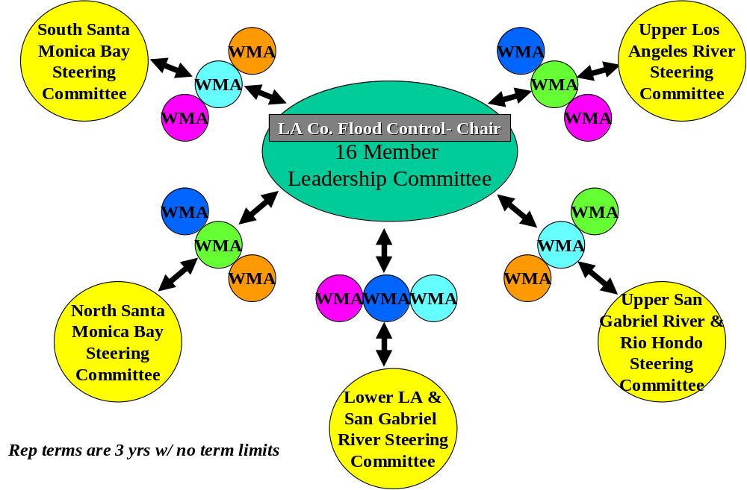

- Give each Steering Committee the responsibility to appoint a representative for one WMA, and rotate the WMA slots between sub-regions on the same term as the LC appointees. This structure would guarantee representation from each WMA while enabling each sub-region to appoint its other two representatives at its discretion. A risk of this structure is that it could force those most knowledgeable WMA representatives out of the process when the WMA slots are shifted between sub-regions. However, this rotation would also guarantee that new perspectives would be brought into the decision-making process at regular intervals.

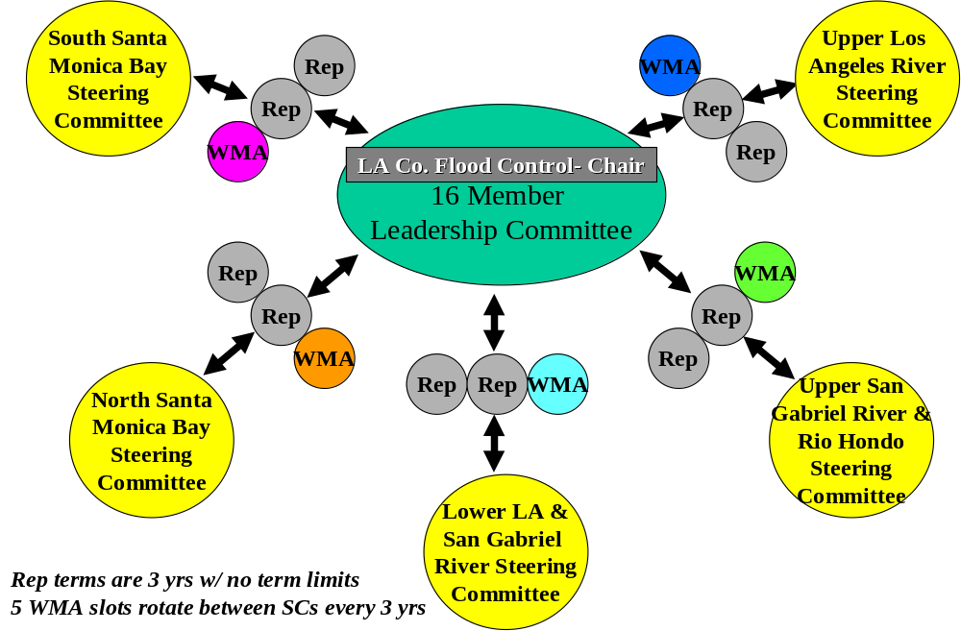

Comments from April Steering Committee Meetings

SC members provided feedback on the decision-making analysis at the April SC meetings. This feedback fell into three areas:

- Roles
- Structure
- Transparency

1. Roles- SCs were generally satisfied with the proposed LC and SC roles. Some participants felt that the proposed SC role of allocating grant funding for project implementation should be a LC role rather than a SC role. One suggestion was to change the SC regarding funding allocation to: “establish a prioritized project list for the allocation of grant funding.” However, others felt that the allocation of funding to specific projects was an appropriate role for the SCs.

2. Structure- Most SCs approved of the suggestion to increase the LC size to representatives from each SC. Most also indicated that specific WMA representatives should be designated in order to ensure a balanced representation of interests. Feedback was mixed on whether WMA representatives should be regional representatives appointed by the LC. The following options were proposed by SCs:
- An 11-12 member LC with 2 representatives appointed by each sub-region with no requirements for WMA representation. If the resulting LC lacked representation from a WMA, the LC would have the authority to appoint a 12th representative to fill that gap.

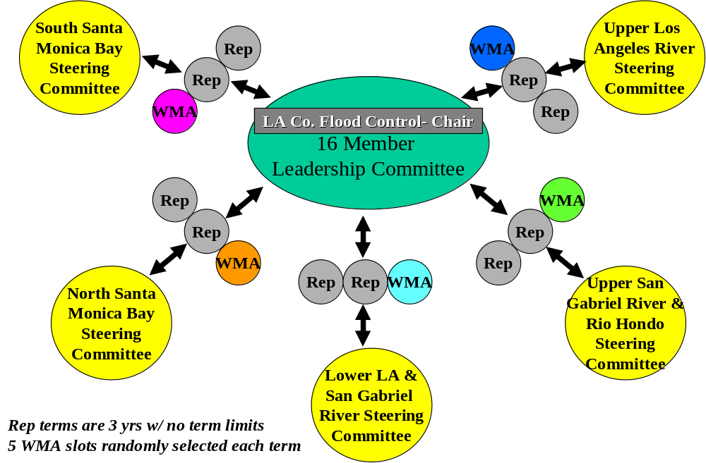

- A 16-member LC with 2 representatives appointed by each sub-region and 5 regional WMA representatives appointed by the LC.

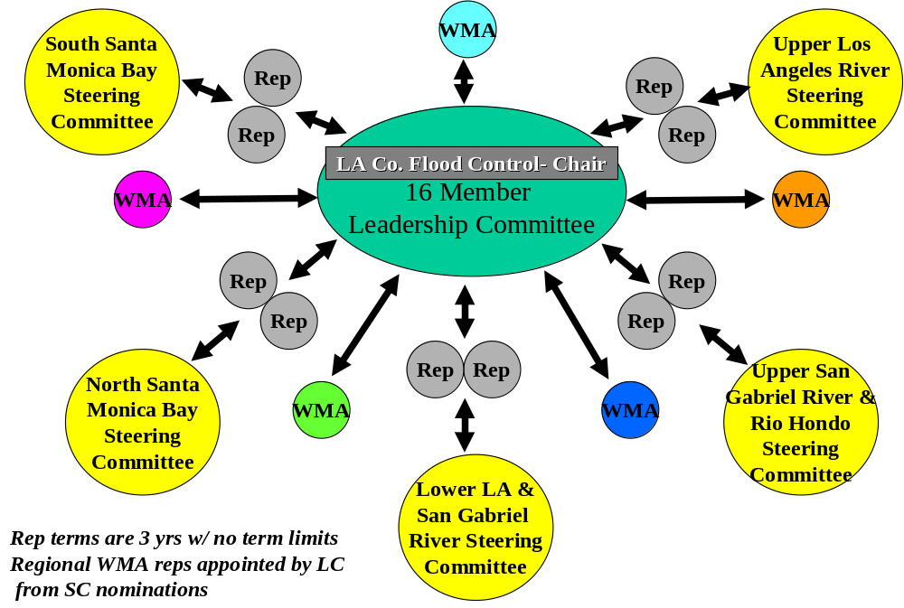

- A 16-member LC with 2 at-large representatives appointed by each sub-region and 1 WMA representative appointed by each sub-region. Which WMA each Steering Committee is responsible for would be determined by random selection.

3. Transparency- SCs were generally satisfied with the suggestions for improving transparency. The suggestion to restructure the LC meeting room as a board format drew some concern, as participants felt that it would hinder consensus-building.

Recommendations from May 3, 2007 Leadership Committee Meeting

The LC at their May 3, 2007 meeting considered the foregoing analysis and voted on the following recommendations to be taken to the SCs for their consideration:

- The LC will be comprised of the Chief Engineer of the Los Angeles County Flood Control District or his/her designee, the Chairs of each of the five sub-regional Steering Committees, one Water Management Area (WMA) representative from each of the SCs, and one additional representative from each of the SCs.
- Each Steering Committee will be responsible for appointing a representative for one WMA. This representative must meet minimum qualifications (to be set by the Leadership Committee). Which WMA each Steering Committee is responsible for will be determined for each term by random selection.
- Each LC member will serve a term of three years. LC members may serve consecutive terms.

The Leadership Committee recommended the following roles and responsibilities for the Leadership Committee:
- Provide regional oversight to the LAIRMWP.
- Track regional progress towards the LA IRWMP targets.
- Act as liaison between the State and the SCs.
- Represents the region’s needs to the State.
- Provide a balance for sub-regional interests.
- Find, coordinate and pursue funding opportunities.
- Provide regional outreach related to the LA IRWMP.
- Periodically update the LA IRWMP.

The Leadership Committee recommended the following roles and responsibilities for the Steering Committee:
- Represent sub-regional interests.
- Provide outreach to local entities and communities to ensure adequate input from all stakeholders.
- Maintain sub-regional prioritized project lists and ensure the LC’s master list is current.
- Maintain a list of sub-regional goals and priorities as appropriate.
- Track progress on sub-regional goals and planning targets (where applicable).
- Identify and sponsor sub-regional planning studies as needed.
- Work with the LC to update the Plan as required.
- Participate in the LC.

The Leadership Committee recommended the following guidelines for transparency:
- The Leadership Committee will prepare and circulate agendas in advance of their meetings. The Steering Committees will have an opportunity to discuss those agendas where possible.
- Time for public comment will be allocated at the beginning of each LC meeting.
- Minutes from LC meetings will be posted on the website and distributed to stakeholders.
- Key action items of the LC will be submitted in a simple board letter format such that subsequent interested parties can review and understand the recommendations and actions.

The Leadership Committee determined a need for further discussion on the following:

- Renaming the Leadership Committee the “Coordinating Council”. This idea will be brought to the SCs for discussion at their May meetings.
- The allocation of grant funding. Further discussion will occur on 1) how grant funding should be divided between the sub-regions and 2) whether the LC or SCs should be responsible for allocating funds for the implementation of projects.

Feedback from May Steering Committee Meetings

The Steering Committees considered the Leadership Committee’s suggested decision-making structure. Most SCs approved of the overall decision-making structure proposed by the LC. The following additions to the proposed decision-making structure were recommended by the SCs:
- The LC must approve SC appointments for WMA representatives. (South Bay SC)
- Consultants will prepare the qualifications to WMA representatives. (South Bay SC)
- Project proponents will abstain from voting on their own projects but should be present for the discussion. A mechanism should be developed to avoid bias in voting (i.e. proponents leave the room or secret ballot) (NSMB SC)
- LC member terms will be staggered in order to maintain continuity (USGR SC; ULA SC)
- One alternate should be elected from each sub-region to serve on the LC in the absence of either representative (NSMB SC)

The ULA SC recommended the following modification to the proposed decision-making structure:
- The initial 11 members of the LC will be responsible for appointing the WMA representatives. WMA representatives must represent the entire region.

The USGR SC recommended the following addition to the Steering Committee Roles and Responsibilities:
- Act as the contact for project proponents and listen to proponents’ concerns (USGR SC)

Comments on whether to rename the LC the “Coordinating Council” included:
- The LC should be renamed the “Regional Coordinating Committee”. Including “regional” in the name indicates that this is the group that the State should communicate with. (USGR SC; ULA SC)
- LLA/SG did not support changing the name of the LC.

The Steering Committees determined a need for clarification on the following:
- Terms- A decision needs to be made on when the three-year terms will begin and whether the LC representatives will need to be re-appointed with the commencement of the terms.
- Long-term funding- a mechanism for long-term funding on the LA IRWMP needs to be established, and the responsibilities of agencies and non-profits in contributing to the funding needs to be articulated.

Next Steps

The LC will consider the SC recommendations for modifications to the proposed decision-making structure and will vote on modifications to the decision-making structure at the June 7th meeting. The decision-making structure will then be embedded into a revised MOU.

Attachment 1

Matrix of Decision-Making Structures



